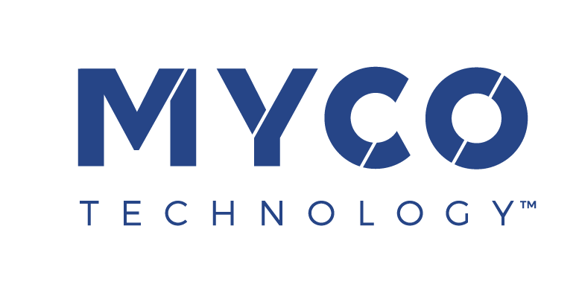

05 January 2023
PRESS RELEASE

MycoTechnology set for European expansion after
EU authorises FermentIQ™ plant-based protein

The European Commission has granted Novel Food status to Pea and Rice Protein Fermented by Shiitake Mushroom Mycelia, trade named FermentIQ™ PTP and TXP, MycoTechnology’s innovative and highly functional natural plant protein ingredients. FermentIQ™ ingredients are produced using a patented mycelial fermentation platform that improves the sensory, functional, and nutritional attributes of plant protein. The authorisation follows a positive opinion issued earlier this year by the European Food Safety Authority (EFSA), which said it considered the product to be safe for use in a wide range of food and beverage categories.

With Novel Food authorisation secured, USA-based MycoTechnology is set to accelerate its expansion into Europe, the company’s next major growth frontier. It has hired its first European sales representatives, based in Germany and the Netherlands, and has recently announced a partnership with Brenntag for distribution in the region. The company’s European expansion will be underpinned by its recent Series E fundraise, which generated $85 million to fuel growth and proliferation of its technology to address the global need for healthier, more delicious food.

Welcoming the news, Alan Hahn, MycoTechnology CEO, commented: “Authorisation means we can now offer food and beverage manufacturers access to our cutting-edge plant protein in Europe for the first time. FermentIQ™ is a transformative, game-changing plant protein with multiple application and nutritional advantages over other plant protein ingredients. It enables brands to overcome the technical and taste barriers associated with other plant proteins, providing consumers with a compelling reason to switch.”

The addition of sales and distribution capabilities in Europe means that MycoTechnology's product portfolio – comprising FermentIQ™ plant proteins and ClearIQ™ flavour clarifiers – is now available globally, with sales networks already in place in North America, Latin America, and Asia.

Alan Hahn added: “Harnessing the power of mushroom mycelia to produce high quality plant protein is perfectly aligned with both consumer expectations and the EU's commitment to sustainability and food security. It’s little surprise, then, that we are already in conversations with leading food industry players in Europe to formulate and commercialize products containing FermentIQ™ plant protein.”

FermentIQ™ is a pea and rice protein blend fermented by mushroom mycelia to deliver superior performance and nutrition. MycoTechnology’s proprietary process deodorizes and de-flavours the protein, so that it offers a more neutral solution with superior functionality in a range of applications. FermentIQ™ is available in both powdered and texturized formats. The core powdered offering (PTP) delivers improved nutrition, taste and mouthfeel profiles that make it ideal for protein beverages and dairy alternatives, and the texturized offering (TXP) provides a superior springy and juicy texture in meat analogues.

FermentIQ™ PTP has a Protein Digestibility Corrected Amino Acid Score (PDCAAS) of 1 for individuals aged 3 and older, signifying that its protein content is of the highest nutritional quality. FermentIQ™ also offers reduced anti-nutrients and improved digestibility, allowing 99.9% of protein consumed to be digested. A recent study found that MycoTechnology's fermentation process improves protein quality by more than 20% for children aged 3+, adolescents, and adults, based on the Digestible Indispensable Amino Acid Score (DIAAS). As a result, FermentIQ™ protein ingredients offer a nutritional value competitive with animal and soy proteins.

ENDS

For more information contact:
Richard Clarke, Ingredient Communications
Tel: +44 (0)7766 256176 | Email: richard@ingredientcommunications.com

About MycoTechnology, Inc.
Established in 2013 and based in Aurora, Colorado, MycoTechnology creates products from mushroom mycelia that solve the biggest challenges in the food industry. The world’s leading explorer of mycelia, MycoTechnology is dedicated to increasing the availability of healthy, sustainable, clean label and high-quality food options through natural mushroom fermentation. Its product portfolio includes ClearIQ™ flavor, a line of transformative mushroom-derived flavor modulation tools that decrease the perception of bitter and off-notes, enable the formulation of products with higher nutrient density, and reduce salt and sugar across a broad spectrum of applications. MycoTechnology also offers FermentIQ™ protein, a line of plant protein products produced via a proprietary fermentation process that harnesses the power of mushroom mycelia to make plant proteins that are more functional, easier to digest, and more delicious. MycoTechnology is a team of near 100 employee-shareholders and continues to recruit additional colleagues to aid expansion and growth.

